**Q. Write a Problem Analysis Chart (PAC), Algorithm and Flowchart for checking whether a Year is Leap or Not.**

PAC

|  |  |  |  |
| --- | --- | --- | --- |
| **Data** | **Processing** | **Output** | **Solution Alternatives** |
| Year | Check if the ‘Year’ is divisible by 4 | Print Leap Year or Not a Leap Year |  |

Algorithm

* Start
* Use variable **Year**
* Read **Year**
* if (**Year**%4==0 and **Year**%100!=0) or **Year**%400==0:

Print “Leap Year”

else

Print “Not a Leap Year”

* Stop

Flowchart

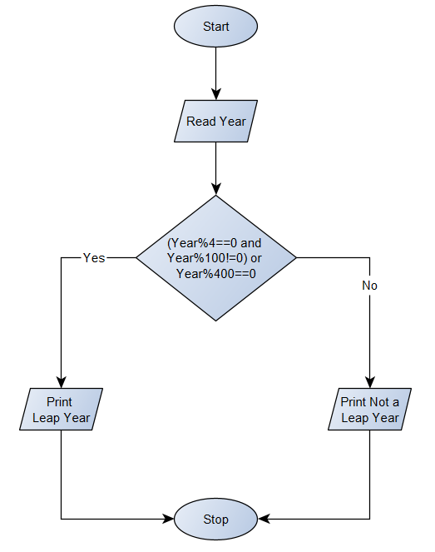

Python Program

Year = int(input(**"Enter a Year : "**))  
if (Year%4==0 and Year%100!=0) or Year%400==0:  
 print(Year, **"is a Leap Year"**)  
else:  
 print(Year, **"is not a Leap Year"**)